**National Society of Professional Surveyors**

### CERTIFICATE OF PARTICIPATION

Is hereby presented to

In recognition of your participation in the

**TRIG-STAR COMPETITION**



2024-2025

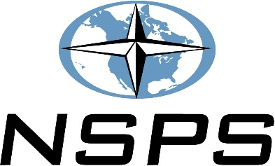

____________________________________________

Trigonometry Teacher

_______________________________________________________

Local Sponsor